Name____________________
DIY Seed Bombs
We are protecting our pollinators!
1 | Add 4-parts clay to 1-part soil.
2 | 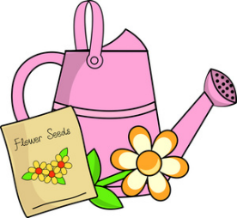  Mix in flower seeds and just enough water to get everything workable.
3 | Mix and squish and mix some more!
4 | Roll mixture into seed bombs.
5 | Toss and enjoy!

