Garden in a Glove

Grade Level(s)
4th grade

Estimated Time
30 minutes

Purpose
Students will observe seeds as they germinate and compare monocots and dicots.

Materials
Food serving gloves
Moist cotton balls
5 different kinds of seeds
Cardstock (Staple the glove to the cardstock)
Review sheet
Recommended: Visit Publications (iowaagliteracy.org)
Books: My Family’s Corn Farm and My Family’s Soybean Farm.
Iowa Ag Today: Plants and Animals
Videos: Dicot: https://www.youtube.com/watch?v=eKo5F87A8a0 Monocot: https://www.youtube.com/watch?v=iFCdAgeMGOA

Vocabulary
- Germination – The process of a plant emerging from a seed and beginning to grow.
- Embryo - The part of a seed that develops into a plant.
- Cotyledon – Part of the embryo within a seed. The cotyledon(s) provide nutrients (food) for the germinating plant. In some plants, they form into the first leaves of the plant, called cotyledon or seed leaves.
- Monocot – A flowering plant with an embryo that has one cotyledon. Grass and corn are examples of monocots.
- Dicot- A flowering plant with an embryo that has two cotyledons. Soybeans and tomatoes are examples of dicots.

Interest Approach – Engagement
Show students the seeds they will be using.
Ask them:
  - What do they have in common?
  - How are they different?
  - What do seeds need to grow?

Procedures
- How does a seed begin to grow? What does it need? Sun (heat- explain why), water, soil (medium to grow in) and air.
- Define Germination. Germination – The process of a plant emerging from a seed and beginning to grow. Cotyledon – Part of the embryo within a seed. The cotyledon(s) provide nutrients (food) for the germinating plant. In some plants, they form into the first leaves of the plant, called cotyledon or seed leaves.
Monocot – A flowering plant with an embryo that has one cotyledon. Grass and corn are examples of monocots.
Dicot- A flowering plant with an embryo that has two cotyledons. Soybeans and tomatoes are examples of dicots.
- Pass out gloves, cotton balls, seeds, and water (bowl or spray bottle).
- Instruct the students to make a seed sandwich with 2 damp cotton balls and a seed or place one seed in with a couple of water beads.
- Students then staple the glove to card stock and will label what plant seed they put in each finger of the glove.
- Place the Garden in a Glove near a window.
- Have the students work individually or in groups to complete the Garden in a Glove worksheet.

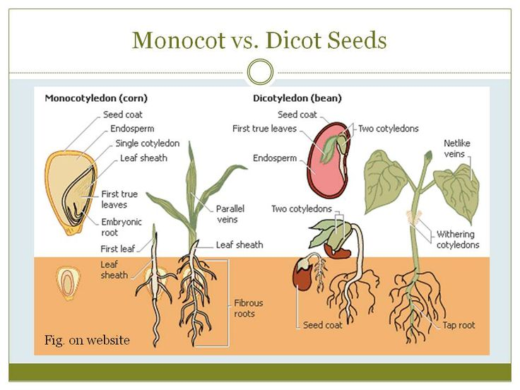
Extension Activities
- During the observation period, have the students create a journal to use for daily observation entries.
- After the experiment is complete, have students create a poster explaining what they witnessed. Include a comparison of the different seeds.
- Bean dissection- Soak lima beans prior to lesson and have the students identify each part of the seed.

Organization Affiliation

National Ag in the Classroom
Agriculture Literacy Outcomes
T1.3-5.b Explain how the interaction of the sun, soil, water, and weather in plant and animal growth impacts agricultural production.
T2.3-5.c Explain how the availability of soil nutrients affects plant growth and development.
Iowa/ Common Core Standards
3-LS1-1. Develop models to describe that organisms have unique and diverse life cycles, but all have in common birth, growth, reproduction, and death.

