Name______________________________
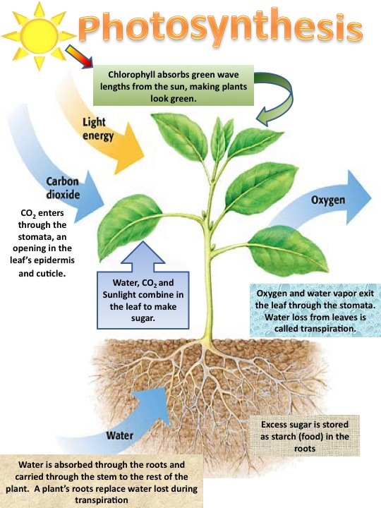

Photosynthesis is a process where plants use________________ from the sun to convert _______________ from the air and ________________ from the soil into _______________ to feed the plant and ________________ is given out in the air.

Plant Food:
This food, simple sugar, can be turned into complex sugars, starches, proteins and many vitamins and minerals. It is stored in roots, stems, leaves, flowers, fruits or seeds, until it is needed later by the plant.
- How does water get from the roots to the leaves? How does the new food, sugar, get from the leaves into the fruit or some other part of the plant for storage?
______________________________________________________________________________________________________________________________________
Food Transfer for Storage:
Plants have a type of system that carries water and food to and from the leaves. Water from the roots goes up the stem trough tiny tubes, called xylem, into the leaves. Remember, that sugar is produced in the leaves. This sugar dissolves in the water and moves down other tiny tubes called the phloem.

- What would happen if these tubes were damaged?
______________________________________________________________________________________________________________________________________

Flower Activity:
We will place a white rose in a vase of water with food coloring. Overtime you will observe what happens to the rose.

- Will the water move in this flower? Yes_____ or No_____
- How will we know that it did? _________________________________________

Look carefully at the stem. Around the end of the stem are the very tiny holes called xylem. The dyed water moved up the stems through these tiny holes.
