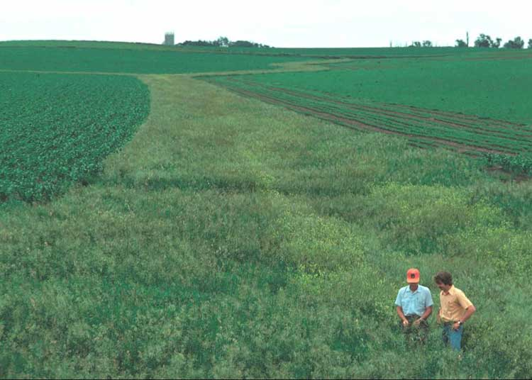

Grassed waterways and field borders are areas of the field put to grass because they are either severely eroding or have the potential to erode.

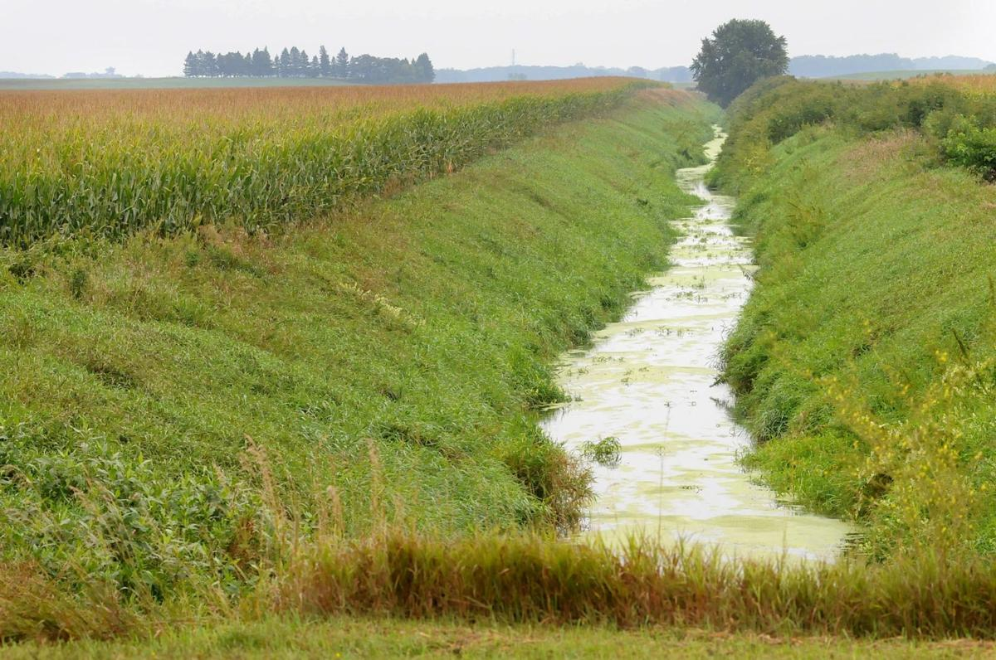

Edge of field buffers Vegetative barriers are narrower buffer strips of hardy, native, perennial grasses or shrubs planted in parallel rows to crops. They are very effective in reducing wind and water erosion which results in sediment trapping and water infiltration.

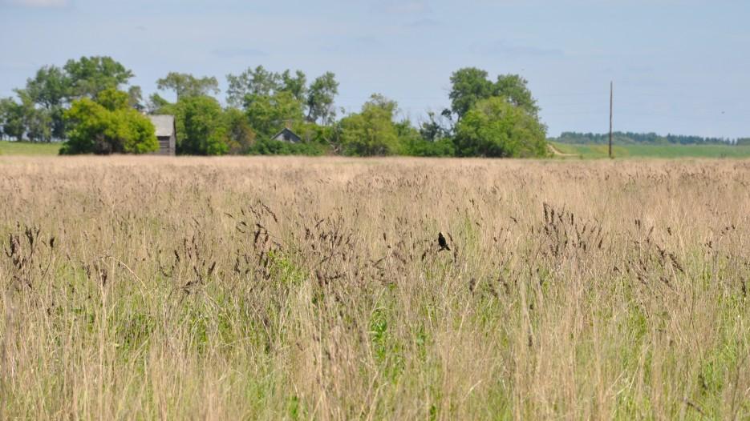

The Conservation Reserve Program (CRP) is a cost-share and rental payment program of the United States Department of Agriculture (USDA). Under the program, the government pays farmers to take certain agriculturally used croplands out of production and convert them to vegetative cover, such as cultivated or native bunchgrasses and grasslands, wildlife and pollinators food and shelter plantings, windbreak and shade trees, filter and buffer strips, grassed waterways, and riparian buffers. The purpose of the program is to reduce land erosion, improve water quality and effect wildlife benefits.

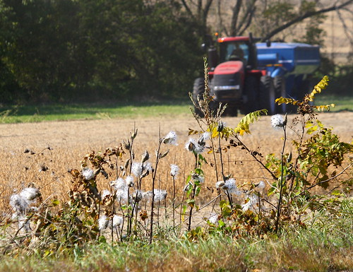
More and more farmers are implementing conservation practices on their farms. They see the value of pollinator habitats- like the milk weed in the photo above.

